Climate Bingo sample card
  Buy local | 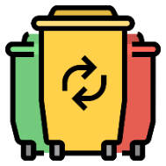  Sort the waste |   Turn off the light | Repair broken objects | 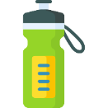  Drink from a reusable bottle
Take the train instead of the plane   | Dry my hair without a hairdryer | Buy produce in my own containers  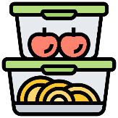 |   Don't waste food | Take public transport  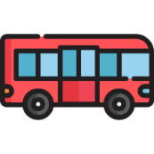
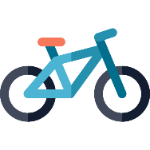  Travel by bike | 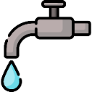  Turn off the tap | PRIZE |   Unplug electronic appliances | Use renewable energy at home  
Don't litter  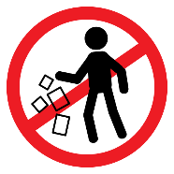 | Exchange books with friends | Keep the heating low  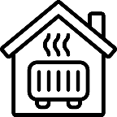 |   Eat fruit and vegetables | Involve other people in climate action
Give home-made gifts   | 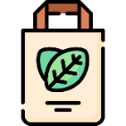  Use reusable bags | Buy second-hand clothes |   Go on foot |   Talk about the environment

Climate Bingo card – add your own contents

List of sample environmental-friendly activities

- Buy local
- Sort the waste
- Turn off the lights
- Repair broken objects
- Drink from a reusable bottle
- Take the train instead of the plane
- Dry my hair without a hairdryer
- Buy produce in my own containers
- Don't waste food
- Take public transport
- Travel by bike
- Turn off the tap
- Unplug electronic appliances
- Use renewable energy at home
- Don't litter
- Exchange books with friends
- Keep the heating low
- Eat fruit and vegetables
- Involve others in climate action
- Give home-made gifts
- Use reusable bags
- Buy second-hand clothes
- Go on foot
- Talk about the environment

